EEE 117 Laboratory

Instructor: Sergio Aguilar Rudametkin

LAB 2: CALCULATION OF INTERNAL RESISTANCE OF VOLTMETER, AMMMETER AND SCOPE

Lab Report by: Amrit Singh

Lab Session: Wednesday

Due Date of the lab: 2/21/18

Date(s) of the lab: 2/07/18

Lab partner(s): Talal Jawaid and Sergio Zavalva

1. **INTRODUCTION:**

In this lab we will learn (or relearn) how to analyze simple circuits designs that model the voltmeter, ammeter (and Scope). We will use our constructed circuits to calculate the internal resistance of the said meters. To do so, we will need to recall circuit analysis techniques presented to us in previous classes, such as Kirchhoff’s Voltage Law and Kirchhoff’s Current Law. It should be noted that the internal resistance of Voltmeter should in high KiloOhms, and the internal resistance of the Ammeter should be in low miliOhms .The purpose of this experiment is to familiarize ourselves with the voltmeter, ammeter and the scope so that we will be able to work with the said meters with ease in future experiments.

1. **PROCEDURE:**

For this experiment we have to calculate the internal resistance of a voltmeter, ammeter, and scope. We will use a circuit design of our choice where KCL, KVL and Voltage Division is applicable. We will start our experiment by measuring the internal resistance across an ammeter, followed by the voltmeter and scope.

1. **ANALYSIS AND DATA:**

**Step 1: Ammeter**

For this part of the lab we set a circuit with two resistors (R1 and R2) in parallel. It was important for us to set the resistors in the circuit in parallel because when measuring the current, resistors in series experience the same current flowing through them. We can see in Figure A that the necessary circuit analysis techniques were performed so that we could use Kirchhoff’s Voltage law in order to find the internal resistance across the ammeter. We measured our resistor values as R1= 10.35Ω and R2= 10.190Ω.

**FIGURE A**

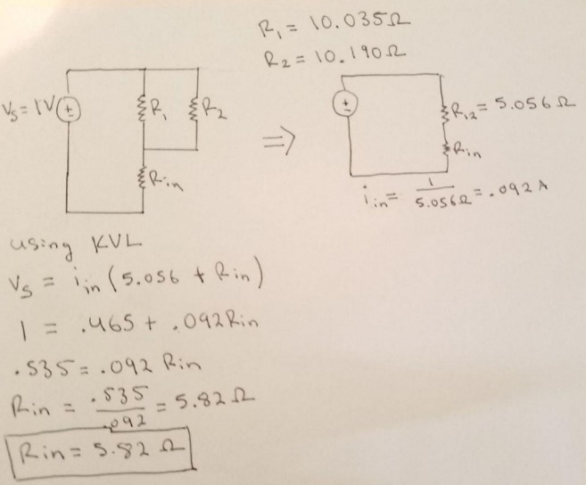

**Step 2: Voltmeter (Scope)**

For this part of the lab we set three resistors R1, R2, R3 in series in order to find the internal resistance of the voltmeter. In order to do this we first measured the voltage across the sum of our resistors R3 and R2. We used voltage division to see that the resistance across the two resistors in series was calculated to be 7.9 Volts as seen in Figure B. our resistors were measured to be R1= 6.319Ω R2=6.293Ω R3=6.285Ω.

**FIGURE B.**

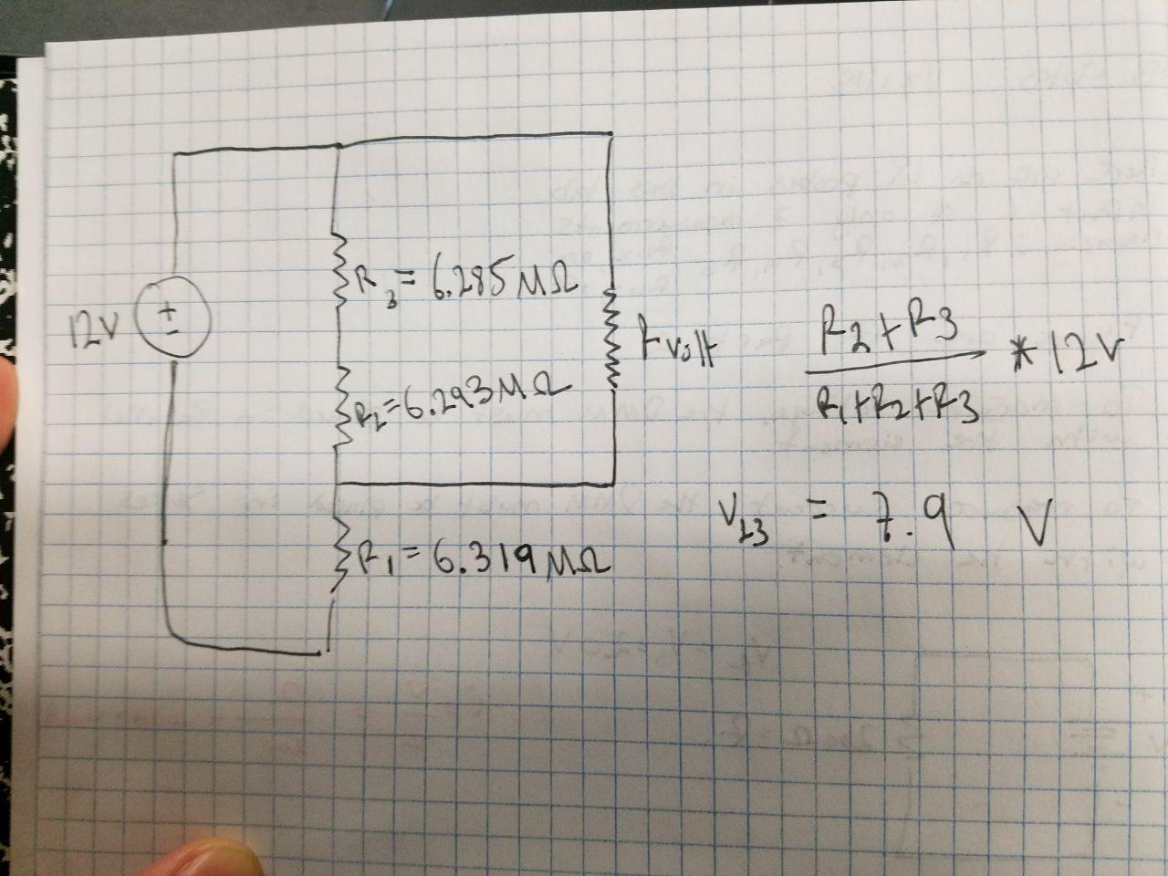

From this point we were able to calculate our internal resistance of the voltmeter. We can see this in Figure C. As for the internal resistance of the scope we measure this value to be 5.75Ω.

**FIGURE C.**

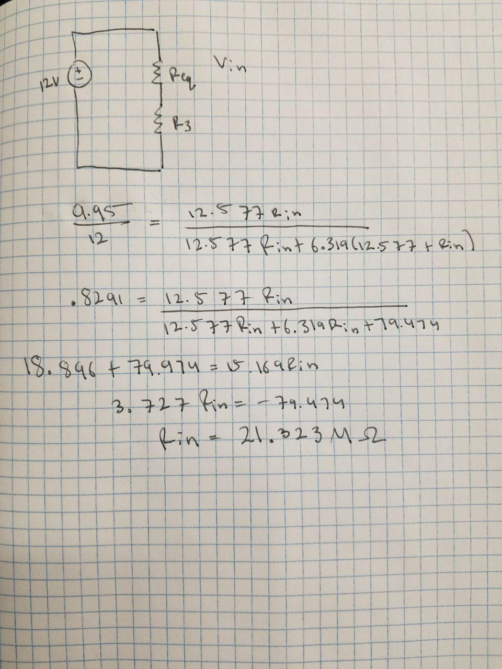

1. **CONCLUSION**

In this lab we learned how to analyze simple circuit’s designs that model the voltmeter, ammeter (and Scope). We used our constructed circuits to calculate the internal resistance of the said meters. We used circuit analysis techniques presented to us in previous classes, such as Kirchhoff’s Voltage Law and Kirchhoff’s Current Law. The purpose of this experiment was to familiarize ourselves with the voltmeter, ammeter and the scope so that we will be able to work with the said meters with ease in future experiments.